Out of office GUIDELINES

Marketing Lab9 Pro

13 May 2026, Kortrijk

Purpose
These guidelines ensure that all out-of-office messages within Lab9 Pro:
- are consistent and professional
- remain customer-focused and clear
- set clear expectations regarding availability and follow-up
- are used in a simple and uniform way across the organization
- quickly direct customers to the correct point of contact

Every out-of-office message must answer at least the following questions:
- When will you be available again?
- Who can help during your absence?
- What should the sender do in case of urgent or specific questions?

Mandatory use
Every employee must use the standard out-of-office templates included in this document. The standard structure and core wording must remain unchanged. Limited additions are permitted when they are functional, relevant and customer-focused.

When should you NOT use an out-of-office message?
Do not use an out-of-office message for:
- meetings or internal appointments
- busy periods or temporary backlog
- minor delays in follow-up
- job or role changes

In the event of a role change, temporarily mention the updated contact details in your email signature for a maximum period of one month.

Structure
Every out-of-office message follows the same standard structure:
- Thank you for your message
- Absence notification
- Replacement or contact person
- Direct contact points (optional)
- Closing sentence

The standard structure and core wording must remain unchanged. Functional additions are only allowed when they are relevant and customer-focused.

General rules
- Always use one of the standard templates included in this document.
- Respect the standard structure and core wording.
- Do not remove mandatory elements from the template.
- Only add functional and customer-focused additions.

- Always assign a replacement or alternative contact point, except for public holidays or central mailboxes.
- Always use correct and up-to-date contact details.
- Keep the out-of-office message as short and clear as possible. Avoid lengthy explanations, multiple alternative contact points or unnecessary information.

- Always write using a customer-friendly and accessible tone of voice.
- Avoid personal explanations or unnecessary context.
- Do not use greetings such as “Dear …”.
- Always use the standard closing sentence.

- Avoid writing complete words or sentences in capital letters, excessive punctuation or overly noticeable formatting.
- Do not use emojis or informal symbols in out-of-office messages.
- Avoid internal abbreviations, jargon or technical terms that may be unclear to customers.

Filling in the fields
Replace all text between [square brackets] with the correct information.
- [date] → date on which you will be available again
- [colleague name / team] → colleague or team following up your communication
- [email address] / [phone number] → replacement contact details

Before activating your out-of-office message, check that all temporary fields have been completed correctly.

Assigning a replacement
For every absence:
- coordinate in advance with a colleague or your team
- clearly determine who will follow up your tasks and communication
- always include correct and up-to-date contact details

Optional contact points
Additional direct contact points are optional and should only be added when relevant to the role, department or absence.

Only use these additions when they:
- Help customers reach the correct contact point faster
- Are operationally relevant
- Remain limited and clearly worded

An out-of-office message may contain a maximum of:
- One primary replacement or contact person
- A maximum of three additional direct contact points

Employees may choose which direct contact points are relevant to their role, department or type of absence. Select a maximum of 3 from the list below. Avoid unnecessary or excessive forwarding.

Direct contact points:
- For general questions: info@lab9pro.be or +32 56 25 55 11.
- For order confirmations, purchase orders or delivery lead times: internalsales@lab9pro.be
- For urgent technical support: our Hotline via +32 56 26 05 78 or hl@lab9.be
- For marketing-related questions: marketing@lab9pro.be
- For HR-related questions: hr@lab9pro.be
- For planning or installation-related questions: planning@lab9pro.be

How to use a template
- Open Outlook > Settings > Automatic Replies
- Select the appropriate out-of-office type
- Copy the complete template
- Paste the text using “Keep Text Only”
- Complete all temporary fields correctly
- Check the content and contact details
- Set the correct start and end date

Which template should I use?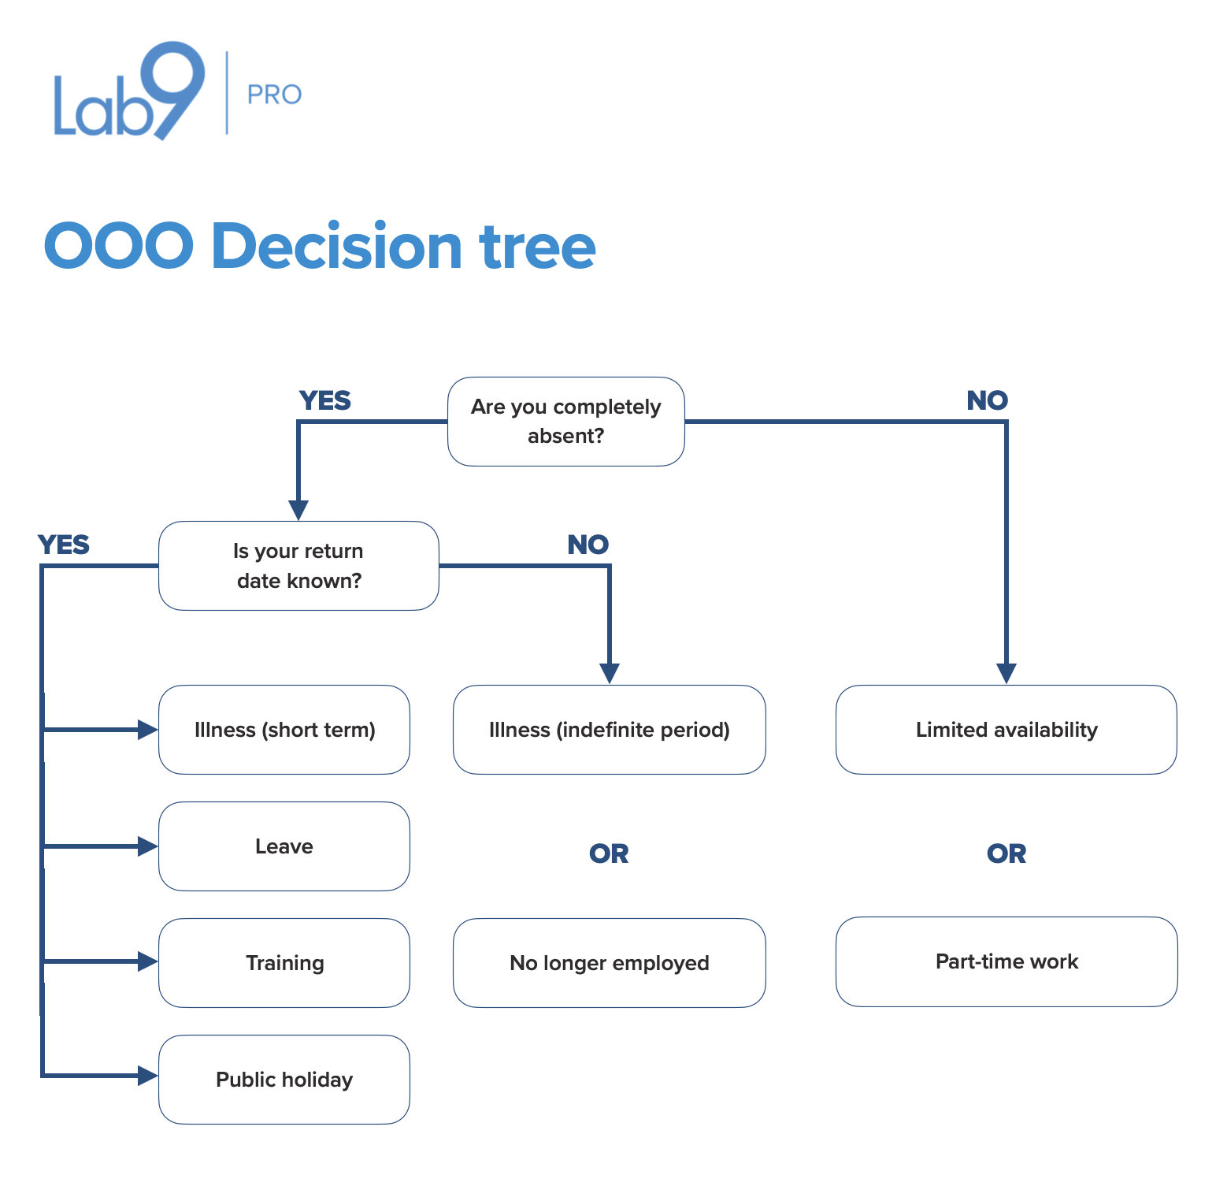

Templates (copy-paste)

Illness (short term)
Thank you for your message.

I am currently absent due to illness and will be available again from [date].

During my absence, my colleagues will ensure that your request is followed up smoothly. You can contact [colleague name / team] via [email address] or by phone on [phone number].

Direct contact points:
- [If relevant, add a maximum of 3 contact points from the standard list]

Our team will be happy to assist you as soon as possible.

[Email signature]

Leave
Thank you for your message.

I am currently on leave and will be available again from [date].

During my absence, my colleagues will ensure that your request is followed up smoothly. You can contact [colleague name / team] via [email address] or by phone on [phone number].

Direct contact points:
- [If relevant, add a maximum of 3 contact points from the standard list]

Our team will be happy to assist you as soon as possible.

[Email signature]

Training
Thank you for your message.

I am currently attending training and will be available again from [date].

For urgent questions, please contact [colleague name / team] via [email address] or by phone on [phone number].

Direct contact points:
- [If relevant, add a maximum of 3 contact points from the standard list]

Our team will be happy to assist you as soon as possible.

[Email signature]

Illness (indefinite period)
Thank you for your message.

I am currently absent due to illness and do not yet have a confirmed return date.

During my absence, my colleagues will ensure that your request is followed up smoothly. You can contact [colleague name / team] via [email address] or by phone on [phone number].

Direct contact points:
- [If relevant, add a maximum of 3 contact points from the standard list]

Our team will be happy to assist you as soon as possible.

[Email signature]

Limited availability
Thank you for your message.

I am currently travelling and therefore have limited availability. I will be fully available again from [date].

For urgent questions, please contact [colleague name / team] via [email address] or by phone on [phone number].

Direct contact points:
- [If relevant, add a maximum of 3 contact points from the standard list]

Our team will be happy to assist you as soon as possible.

[Email signature]

Part-time work
Thank you for your message.

I currently have limited availability and am absent on [day] [every x weeks]. This may result in a slightly longer response time.

For urgent questions, please contact [colleague name / team] via [email address] or by phone on [phone number].

Direct contact points:
- [If relevant, add a maximum of 3 contact points from the standard list]

Our team will be happy to assist you as soon as possible.

[Email signature]

No longer employed
Thank you for your message.

[Name] is no longer employed at Lab9 Pro.

For further follow-up, please contact [colleague name / team] via [email address] or by phone on [phone number].

For general questions, you can always contact us via info@lab9pro.be or +32 56 25 55 11.

Our team will be happy to assist you as soon as possible.

Public holiday
Thank you for your message.

We are closed today due to a public holiday. We will process your message as soon as possible from [date].

Our team will be happy to assist you as soon as possible.

Mailbox without active follow-up (only for newsletter@lab9pro.be)
Thank you for your message. This mailbox is not actively monitored.

For questions or support, please contact marketing@lab9pro.be. Our team will be happy to assist you as soon as possible.

