**Lemahieu Group strengthens market position with acquisition of Lambrechts Hout’s activities**

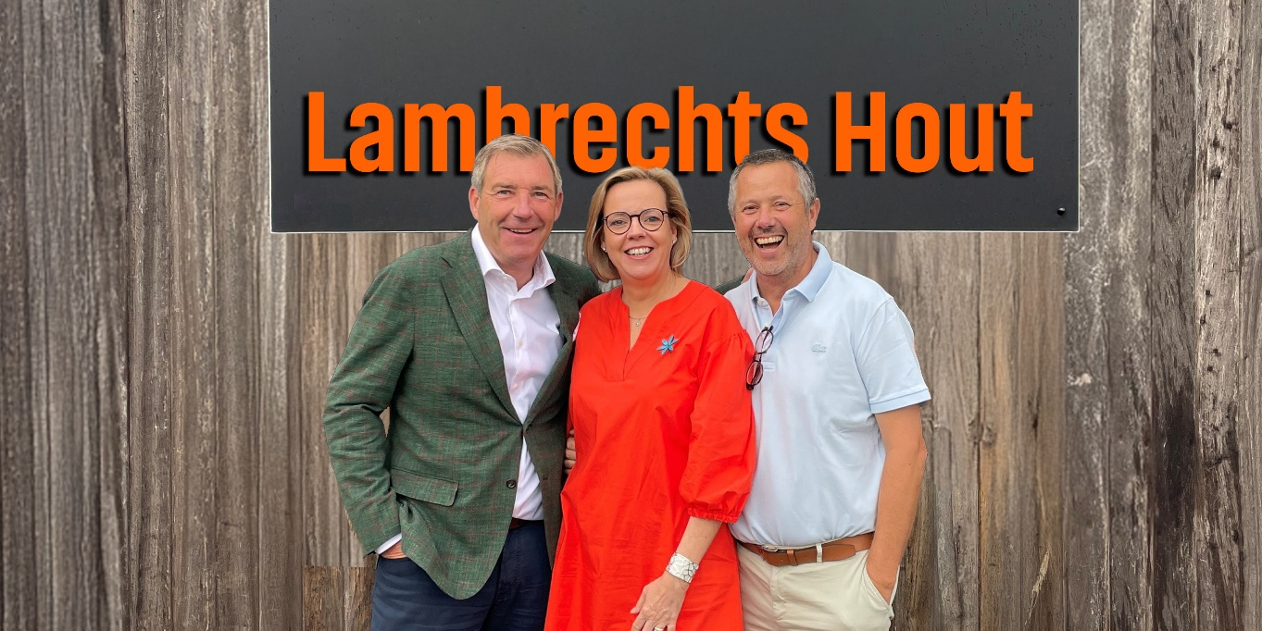Ghent, Ostend, Antwerp — July 1, 2025  
**Lemahieu Group, the Belgian timber and panel importer with an extensive machinery park in Ostend, will acquire the activities of Antwerp-based Lambrechts Hout as of July 1, 2025. This strategic move strengthens Lemahieu Group's market position in the Benelux.**

**Family businesses with strong roots in the timber industry**

Founded in 1911 by the Lemahieu family, Lemahieu Group has grown under the supervision of Mike Lemahieu, the fourth-generation owner, into a key player in the import of timber and panels (Lempan Panels) and in providing timber solutions.

With a comprehensive machinery park for sawing, planing, impregnation, dipping, CNC processing, thermal modification (LDCwood® ThermoWood®), and fire-retardant treatment (Lemahieu Fire Protection®), Lemahieu Group is a reliable partner for the timber and construction trade and the wood processing industry in Belgium and abroad.

With two sites in Belgium, a logistics hub in Honfleur (France), and a subsidiary, JenoWood, in the Netherlands, the group generates an annual turnover of €125 million.

Lambrechts Hout was founded in 1937 by the grandfather of the current owners. 88 years later, the company, located in the Port of Antwerp, remains family-owned. Jan and Marleen Lambrechts have been in charge since 2008.

As a specialist in structural timber, Lambrechts Hout supplies exclusively to the timber and construction trade and the wood processing industry.

**Shared values of drive, collaboration, service, and quality**

Both companies share a culture of trust, loyalty, and service orientation towards their customers, suppliers, and employees. This shared DNA facilitates the integration of Lambrechts Hout’s operations within Lemahieu Group, ensuring continued quality and service to customers. Jan Lambrechts will take on an active role within Lemahieu Group.

“*We’re delighted to have reached an agreement with Mike to transfer our operations to Lemahieu Group, a family business that shares our values and passion for wood. For us, Lemahieu Group was clearly the most logical and best partner. We already had a good relationship with Mike, and we’re confident that our customers can continue to rely on the same trusted service and continuity they’ve known over the past 88 years*,” **confirm Jan and Marleen Lambrechts.**

“*Lambrechts Hout fits perfectly within our vision — a family-rooted business with a strong focus on quality and customer service, and a genuine passion for wood*,” **says Mike Lemahieu**.  
“*We look forward to creating new opportunities together with Jan Lambrechts.*”

----------------------------------------- END OF PRESS RELEASE --------------------------------------

**About Lemahieu Group NV**

Lemahieu Group is a family-owned company with more than 100 years of experience in the timber and panel industry. Since its foundation in 1911, the company has been known for its high-quality products and customer-oriented service.

Lemahieu Group's mission is to expand the applications of timber and panels as a sustainable (building) material. They do this by investing in ecologically sound solutions.

Their strength lies in the cooperation between the various divisions and the specialised expertise of their employees.

With a strong focus on innovation and sustainability, Lemahieu Group has positioned itself as a trusted partner for the timber and construction trade and the wood processing industry.

Driven by the values of quality, drive and craftsmanship, Lemahieu Group remains committed to customer satisfaction and ensures long-term relationships with both customers and employees.

[www.Lemahieu.be](http://www.Lemahieu.be)

**About Lambrechts Hout NV**

Lambrechts Hout was founded in 1937 by the grandfather of the current managers, Jan and Marleen Lambrechts. After spending 36 years in Deurne and 47 years in Mortsel, the company relocated to the Port of Antwerp in 2020 for logistical reasons.

Specialising in planed timber products such as slats, rafters and profiles, Lambrechts Hout has developed into a reliable partner for the timber and construction trade and the wood processing industry over the past 25 years. Thanks to its four planing lines, the company can supply high-quality finished products that fully reflect its core value of prioritising quality.

**LEMAHIEU GROUP**

**Company headquarters**  
Zuiddokweg 44  
9000 Ghent  
Belgium  
+32 9 255 58 88  
[gent@lemahieu.be](mailto:gent@lemahieu.be)  
[www.lemahieu.be](http://www.lemahieu.be)

**Production**Vergunningenstraat 6  
8400 Ostend  
Belgium  
+32 59 33 99 99  
[oostende@lemahieu.be](mailto:oostende@lemahieu.be)

**LDCwood NV ThermoWood®**Vergunningenstraat 7  
8400 Ostend  
Belgium  
 [+32 59 50 55 14](tel:+3259505514)   
[Protectedbynature@ldcwood.com](mailto:Protectedbynature@ldcwood.com)  
[www.LDCwood.com](http://www.LDCwood.com)

**Press contact**   
Leen Van den Broeck  
[l.vandenbroeck@lemahieu.be](mailto:l.vandenbroeck@lemahieu.be)   
0486 58 98 04